**ASSIGNMENT NO-1**

### Project Name: Smart Farmer - IoT Enabled Smart Farming

### Application

**Batch Number: B5-5M1E**

**Assignment Topic**: smart home automation using sensor LEDs and buzzer

Team Lead : Vishnu Vardhan Devarampati

Team Member-1: Choppara Sreecharan

Team Member-2: Sangani Bhanu Chand

Team Member-3: Karthi

Before Simulation

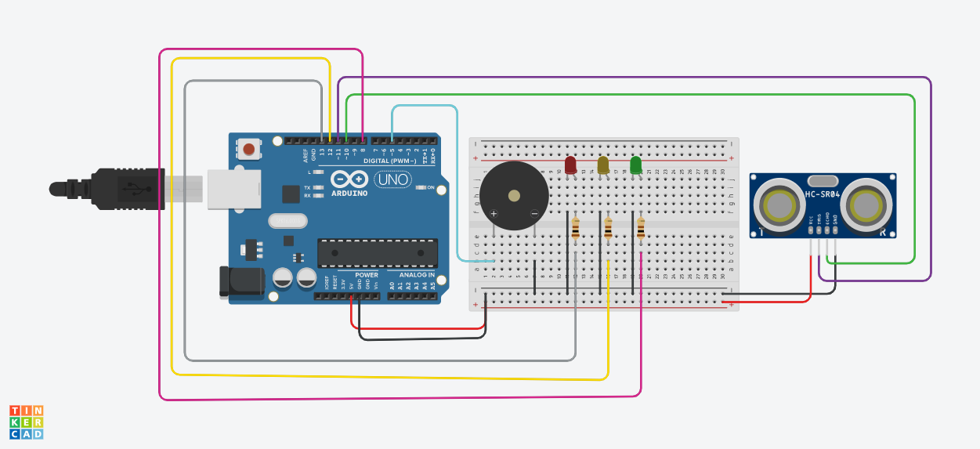

After Simulation

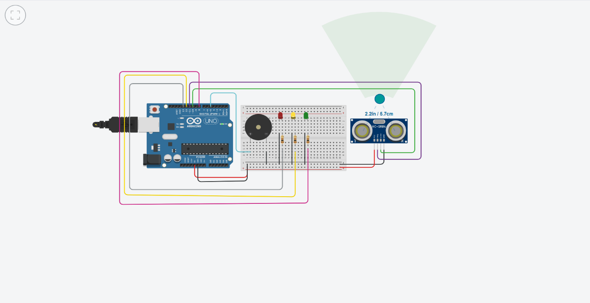

**Code:**

